🌟 Subtraction 1°
- Represent the number on top:  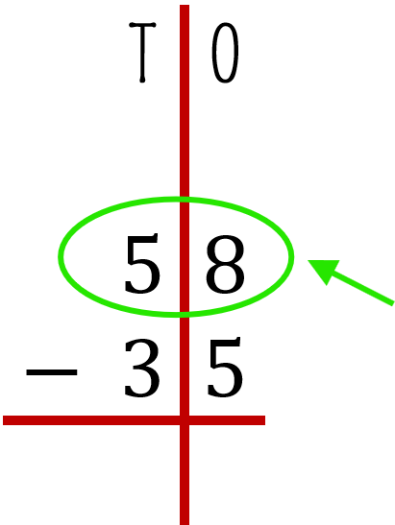 | 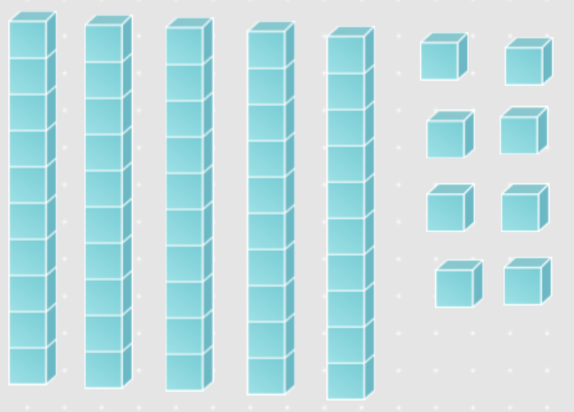
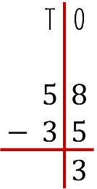  - start with the ones. you need to solve 8 minus 5. | 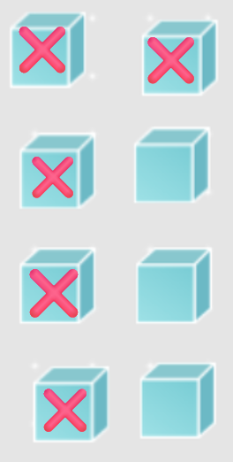
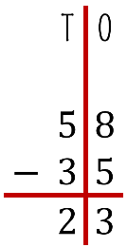  - Continue with tens. you need to solve 5 minus 3. | 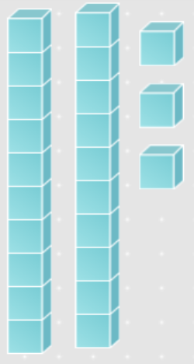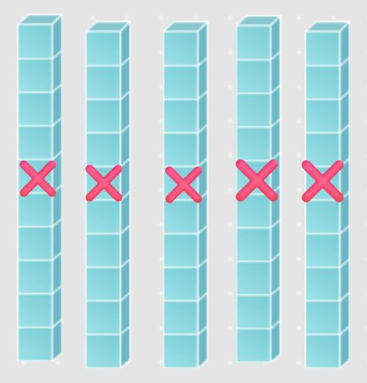
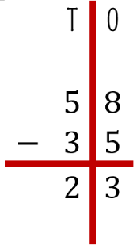  So $58-35=23$ | 

🌟 Subtraction 1°
- Represent the number on top:   | 
  - start with the ones. you need to solve 8 minus 5. | 
  - Continue with tens. you need to solve 5 minus 3. | 
  So $58-35=23$ | 

